Application for Charitable Organizations
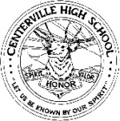
CHS Spirit Chain 2013

Centerville High School
500 E.Franklin Street
Centerville, OH 45459

Official Name of Charitable Organization:

Mailing Address of Charitable Organization:

Charity Website: | Charity Facebook:
Charity E-Mail Address: | Other Social Media:

Contact Person: | Phone #: | E-Mail Address:

Describe Your Organization:

Specify the purpose or object for which funds collected by Spirit Chain will be used. Attach additional sheets or information if necessary:

